**Basic File Management and System Navigation Tutorial for Business Students (Windows and macOS)**

**Table of Contents**

1. [Introduction](https://chatgpt.com/c/67ec132e-c5dc-8001-8343-f4aa068e11e6#introduction)
2. [Section 1: File Systems and File Organization](https://chatgpt.com/c/67ec132e-c5dc-8001-8343-f4aa068e11e6#section-1-file-systems-and-file-organization)
3. [Section 2: File Paths](https://chatgpt.com/c/67ec132e-c5dc-8001-8343-f4aa068e11e6#section-2-file-paths)
4. [Section 3: File Management Using GUI](https://chatgpt.com/c/67ec132e-c5dc-8001-8343-f4aa068e11e6#section-3-file-management-using-gui)
5. [Section 4: ZIP Archives](https://chatgpt.com/c/67ec132e-c5dc-8001-8343-f4aa068e11e6#section-4-zip-archives)
6. [Section 5: Command Line Basics](https://chatgpt.com/c/67ec132e-c5dc-8001-8343-f4aa068e11e6#section-5-command-line-basics)
7. [Section 5B: More Command Line Practice](https://chatgpt.com/c/67ec132e-c5dc-8001-8343-f4aa068e11e6#section-5b-more-command-line-practice)
8. [Additional Activities](https://chatgpt.com/c/67ec132e-c5dc-8001-8343-f4aa068e11e6#additional-activities)
9. [Additional Skills for Business and Data Analysts](https://chatgpt.com/c/67ec132e-c5dc-8001-8343-f4aa068e11e6#additional-skills-for-business-and-data-analysts)
10. [Bonus Challenge Activities and Quizzes](https://chatgpt.com/c/67ec132e-c5dc-8001-8343-f4aa068e11e6#bonus-challenge-activities-and-quizzes)
11. [Section 6: File Naming and Metadata](https://chatgpt.com/c/67ec132e-c5dc-8001-8343-f4aa068e11e6#section-6-file-naming-and-metadata)
12. [Section 7: Final Challenge Project](https://chatgpt.com/c/67ec132e-c5dc-8001-8343-f4aa068e11e6#section-7-final-challenge-project)
13. [Conclusion](https://chatgpt.com/c/67ec132e-c5dc-8001-8343-f4aa068e11e6#conclusion)
14. [Optional Resources](https://chatgpt.com/c/67ec132e-c5dc-8001-8343-f4aa068e11e6#optional-resources)

**Introduction**

Understanding file management is essential for success in the modern workplace. As a business professional, you will often be required to organize, store, and retrieve data effectively. This tutorial will walk you through foundational concepts and practical exercises for file organization and manipulation on both Windows and macOS. You will learn to:

* Understand file systems and directory structures
* Work with file paths (absolute and relative)
* Navigate and manage files/folders using GUI and command line
* Work with file archives (ZIP files)
* Understand file naming conventions and metadata

This guide includes step-by-step activities with instructions and reflection questions to reinforce learning. You’ll finish with a final challenge to put everything together.

**Section 1: File Systems and File Organization**

**What this section is about:** Understanding how operating systems store and organize files using hierarchical structures. This includes concepts like drives, directories, folders, and file types.

**Why it matters:** Knowing the structure of a file system helps you store, find, and manage information efficiently. In business settings, you will frequently work across different platforms.

**Key Concepts**

* **Drive (Windows)**: Usually labeled as C:\, D:\, etc., these represent storage devices.

* **Volume (macOS)**: Drives are shown as volumes and mounted in /Volumes/
* **Folder vs. Directory**: Folders (GUI term) and directories (CLI term) are the same — containers for files.

**Activity: Explore File Systems**

**Objective:** Explore and compare file system structure on Windows and macOS

**Windows:**

1. Open File Explorer.

1. Locate This PC → observe the available drives.

1. Click C:\ drive and navigate to Users → YourName → Documents.

1. Observe folders like Desktop, Downloads, etc.

**macOS:**

1. Open Finder.
2. From the menu bar, click Go → Computer
3. Open Macintosh HD → Users → YourName → Documents
4. Explore the visible folders.

**Reflection:**

* What folders are created by default?

* How are files named differently between systems?

**1. Windows (NTFS/FAT32)**

* **Path Separator:** \ (backslash)
* **Case Sensitivity:** *Case-insensitive*, but case-preserving (e.g., File.txt = file.txt)
* **Illegal Characters:**  
  \ / : * ? " < > |
* **Reserved Names:**  
  CON, PRN, AUX, NUL, COM1–COM9, LPT1–LPT9
* **Max Path Length:** 260 characters (can be extended in modern Windows)

**2. macOS (APFS/HFS+)**

* **Path Separator:** / (forward slash)
* **Case Sensitivity:** Usually *case-insensitive*, but *case-sensitive* variants exist (depends on format)
* **Illegal Character:** / (colon : was used in classic Mac OS)
* **Reserved Names:** No special reserved names like Windows
* **Max Path Length:** 1024+ characters depending on format

**Section 2: File Paths**

**What this section is about:** Learning the difference between absolute and relative file paths.

**Why it matters:** Understanding paths allows you to locate and access files programmatically or across networks.

**Key Concepts**

* **Absolute path**: A full path starting from the root of the file system.
* **Relative path**: A path that starts from the current working directory.

**Activity: Understand Paths**

1. Create a folder named MyProjects in your Documents folder.

1. Inside it, create another folder Reports.

1. Add a text file named summary.txt.

1. Use CLI to navigate and identify both absolute and relative paths to the file.

**Commands (macOS/Windows Git Bash):**

cd ~/Documents/MyProjects/Reports

pwd # shows absolute path

cd # shows absolute path in Windows command line (cmd)

**Reflection:**

* Why are relative paths useful in team settings?

Relative paths are useful in team settings because they make code portable, version-control friendly, and environment-independent. They ensure consistency across machines, simplify collaboration, and support automation and CI/CD workflows by avoiding hardcoded, machine-specific file locations.

**Section 3: File Management Using GUI**

**What this section is about:** Learning to manage files and folders using graphical user interfaces (GUIs) in Windows and macOS.

**Why it matters:** Most users begin their file management experience with GUIs. Mastery of drag-and-drop, shortcuts, file search, and organization will save time and avoid confusion.

**Activity: Organize Coursework Files**

**Objective:** Create a structured directory for class materials.

**Windows:**

1. Open File Explorer.

1. Navigate to Documents

1. Create a folder called Fall_2025_Courses

1. Inside it, create subfolders: Accounting, Marketing, Analytics, Ethics

1. Move appropriate files into each folder.

**macOS:**

1. Open Finder.
2. Go to Documents
3. Create the folder Fall_2025_Courses
4. Inside it, create the same four subfolders.
5. Drag and drop files into place.

**Reflection:**

* How does organizing files help you stay on track with deadlines?

Organizing files helps you meet deadlines by saving time, reducing errors, clarifying priorities, and making collaboration smoother; so you can focus on the work, not finding it.

* What’s the difference between “copy” and “move” operations?

**Copy** creates a duplicate and keeps the original; **move** relocates the file and removes it from the original location.

**Section 4: ZIP Archives**

**What this section is about:** How to compress and extract file archives using built-in utilities.

**Why it matters:** ZIP files are used to send multiple files efficiently, especially over email or cloud storage.

**Activity: Practice Compression**

**Objective:** Learn to zip and unzip files.

**Windows:**

1. Right-click a folder (e.g., Analytics) → Select Send to → Compressed (zipped) folder

1. Rename the resulting .zip file.

1. Right-click it and choose Extract All…

**macOS:**

1. Control-click a folder → Select Compress "FolderName"
2. Double-click the resulting .zip to unzip it.

**Reflection:**

* What happens to the original folder when you compress it?

Remains unchanged

* Why is compression useful for assignments and backups?

Compression saves space, speeds up transfers, keeps files organized, and protects data—making it ideal for both assignments and backups

**Section 5: Command Line Basics**

**What this section is about:** Learning to navigate and manipulate files using a command-line interface (CLI) such as Terminal on macOS or Git Bash/Command Prompt on Windows.

**Why it matters:** Command-line tools are essential for automation, efficient file handling, and working on remote systems or cloud platforms. These skills give you more control over your environment and make you more competitive in technical roles.

**Key Concepts:**

* **Command Line Interface (CLI)**: A text-based way to interact with your operating system
* **Directory Navigation**: Moving through folder structures without a mouse
* **Creating and Managing Files**: Using commands to make, rename, and organize your content

**Activity: Basic CLI Navigation**

**macOS:**

cd ~ # Go to home folder

mkdir CLI_Training # Create a new folder

cd CLI_Training

touch notes.txt # Create a file

ls # List contents

**Windows (cmd):**

cd ~

mkdir CLI_Training

cd CLI_Training

copy NUL notes.txt

dir

**Explanation of Commands:**

* cd changes directory
* mkdir creates a new folder
* copy NUL creates a blank file
* dir lists contents of a directory

**Reflection:**

* What happens when you type a wrong command?

Getting an error. Such as: The system cannot find the path specified

* How do you clear the terminal screen?

Using the cls

**Section 6: File Naming and Metadata**

**What this section is about:** Establishing meaningful, consistent file names and understanding file metadata.

**Why it matters:** Good naming conventions save time and prevent confusion. Metadata helps you track file history, size, and use.

**Best Practices:**

* Use lowercase and underscores (project_summary_2025.xlsx)
* Include versioning (e.g., _v1, _v2)
* Avoid spaces and special characters

**Activity: File Naming Practice**

**Objective:** Practice renaming files and reviewing metadata.

1. Collect several class documents with unclear names.
2. Rename them using a clear structure: [topic]_[type]_[date].ext

1. View properties:
   * **Windows**: Right-click → Properties
   * **macOS**: Right-click → Get Info

**Reflection:**

* What are the benefits of consistent naming?

Easier tracking and retrieval of files

* What metadata is most helpful for tracking edits?

Key metadata like timestamps, author info, version numbers, and change logs help track when edits were made, by whom, and what changed.

**Section 7: Final Challenge Project**

**What this section is about:** A comprehensive, hands-on project to apply everything you’ve learned.

**Why it matters:** It simulates a real-life deliverable — organizing work, archiving, and presenting it in a professional way.

**Challenge Instructions:**

1. Create a folder called FinalProject in your Documents folder.

1. Inside, recreate a directory structure like:

FinalProject/

├── data/

├── notes/

├── outputs/

├── reports/

1. Add dummy files in each folder.
2. Write a README.txt file to explain the structure.

1. Compress the folder into a .zip file.

1. Share or upload your .zip to a cloud drive.

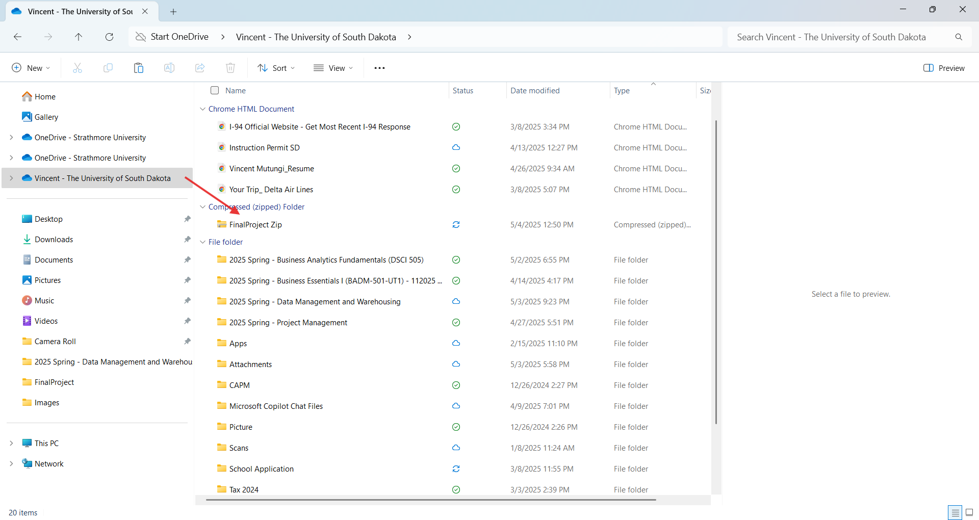

**Reflection:**

* What did you learn from organizing the project from scratch?

Organizing a project from scratch, like a class assignment, teaches planning and structure, time management, problem-solving, attention to detail, collaboration readiness, and workflow efficiency, enhancing academic and professional skills.

* What would you do differently in a team environment?

In a team environment, I’d use shared naming conventions, add a collaboration directory and README.md, set up a git repository, define access permissions, and schedule regular syncs to enhance coordination and reduce conflicts

**Section 8: Additional Activities**

**What this section is about:** Applying what you’ve learned to new real-world situations and refining your organizational skills across platforms.

**Why it matters:** You’ll encounter different file formats, transfer methods, and collaboration setups in the workplace. These activities simulate that variety.

**Activity: Compare File Systems**

**Objective:** Understand differences between NTFS (Windows) and APFS (macOS).

1. Search for key features of each system.
2. Compare support for: case sensitivity, encryption, max file size, compression.
3. Fill in a comparison table.

|  |  |  |
| --- | --- | --- |
| **Feature** | **NTFS (Windows)** | **APFS (macOS)** |
| **Case Sensitivity** | Not case-sensitive by default; treats "File.txt" and "file.txt" as the same. | Supports case sensitivity as an option (e.g., APFS Case-sensitive); can treat "File.txt" and "file.txt" as different files if enabled. |
| **Encryption** | Supports file and folder encryption via Encrypting File System (EFS); full disk encryption with BitLocker (Windows 8.1+). | Natively supports full disk and file-level encryption; offers single-key, multi-key, and per-file key encryption for enhanced security. |
| **Max File Size** | Up to 16 EB (exabytes) on Windows Server 2019+ and Windows 10 (v1709+); older versions support up to 16 TB. | Up to 8 EB (exabytes); supports over 9 quintillion files with 64-bit inode numbers. |
| **Compression** | Supports transparent file and folder compression; compressed files can be accessed without third-party decompression. | Supports transparent compression on individual files using Deflate, LZVN, or LZFSE; no full disk compression. |

**Activity: Create a Weekly Backup Folder System**

**Objective:** Simulate manual backup routine.

1. Create a folder Backups
2. Inside, add Monday through Sunday

1. Copy working files into correct day’s folder
2. Zip one day’s folder and note pros/cons

**Activity: Cross-Platform File Transfer**

**Objective:** Share zipped files across systems.

1. Create and compress folder on one OS
2. Extract and open on another OS
3. Report what worked and what didn’t

**Section 9: Additional Skills for Business and Data Analysts**

**What this section is about:** Going beyond basic file handling to include critical skills like file versioning and working with structured data.

**Why it matters:** These skills make you more efficient and collaborative in real data work.

**Activity: Manual File Versioning**

1. Create a folder with files: summary_v1.txt, summary_v2.txt, etc.

1. Document changes in each version
2. Explain which version to deliver and why

The Summary_v3.txt because it is the latest in the version history

**Activity: Structured Data Awareness**

1. Download a public dataset (CSV)
2. Store in a folder DataImports_2025
3. Copy and rename it backup_data.csv
4. Practice referencing its path in a script

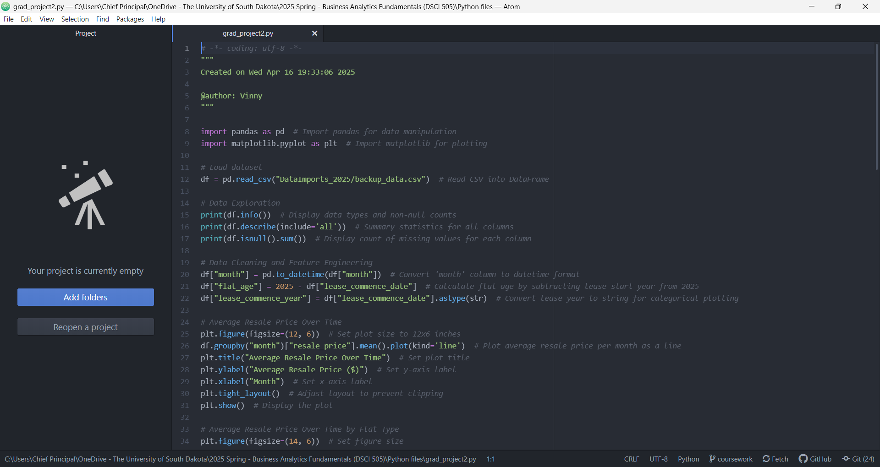

**Section 10: Bonus Challenge Activities and Quizzes**

**Challenge: Script-Based File Organizer**

**Objective:** Automate file organization by month.

1. Create dummy files like report_2025_04_01.txt
2. Create folders: April, May, June
3. Use CLI to move files into folders based on name pattern

**Quiz**

**Match the terms:** A. Root directory → 2. Top-most folder B. Relative path → 3. Documents/report.docx C. Absolute path → 1. /Users/Alex/Documents/report.docx

**True/False:**

1. NTFS supports case sensitivity by default → False
2. macOS uses backslashes in paths → False
3. ZIP files can store folder structures → True

**Short Answer:**

* Why use relative paths in team folders?

**Answer Key**

1. B, 2. C, 3. A T/F: False, False, True Short Answer: Keeps paths portable across systems and locations.

**Section 11: CLI Quick Reference Sheet**

Here’s a handy cheat sheet for commonly used command-line operations in analytics workflows. Commands are listed with explanations and examples.

**Navigation and Listing**

| **Command (macOS/Linux)** | **Windows (Git Bash)** | **Description** |
| --- | --- | --- |
| pwd | cd | Print working directory |
| ls | dir | List files in directory |
| cd foldername | cd foldername | Change directory |
| cd .. | cd .. | Go up one level |

**File and Directory Management**

| **Command** | **Description** |
| --- | --- |
| mkdir foldername | Create a new folder |
| copy NUL file.txt  touch file.txt | Create a new empty file (Windows)  Create a new empty file (macOS) |
| copy file1 file2  cp file1 file2 | Copy file1 to file2 (Windows)  Copy file1 to file2 (macOS) |
| cp -r folder1 folder2 | Copy a folder and contents recursively (macOS only) |
| move file1 newname  mv file1 newname | Rename or move file (Windows)  Rename or move file (macOS) |
| del file.txt  rm file.txt | Delete file (Windows)  Delete file (macOS) |
| rmdir -r folder  rm -r folder | Delete folder and contents (Windows)  Delete folder and contents (macOS) |

**Viewing and Processing Files**

| **Command** | **Description** |
| --- | --- |
| type file.txt  cat file.txt | View contents of a file (Windows)  View contents of a file (macOS) |
| head file.csv | View first 10 lines (macOS only) |
| tail file.csv | View last 10 lines (macOS only) |
| Find /c /v file.csv  wc -l file.csv | Count lines in file (Windows)  Count lines in file (macOS) |
| findstr term file  grep 'term' file | Search for 'term' in file (Windows)  Search for 'term' in file (macOS) |

**File Archiving**

| **Command** | **Description** |
| --- | --- |
| zip -r archive.zip folder/ | Zip a folder and its contents |
| unzip archive.zip | Unzip a ZIP file |

**Git Basics**

| **Command** | **Description** |
| --- | --- |
| git init | Initialize Git repository |
| git add . | Stage all files |
| git commit -m "msg" | Commit with message |
| git status | Check changes since last commit |
| git log | View commit history |
| git clone URL | Clone remote repository |
| git push | Push changes to GitHub |

**Section 12: Conclusion**

**What this section is about:** Summarizing key takeaways from the tutorial and preparing you for professional use of file systems and navigation tools.

**Why it matters:** File management skills are foundational to all technical roles. Being fluent in organizing, navigating, and archiving makes you more confident and valuable as a student, analyst, or employee.

**Key Takeaways:**

* Consistent naming and structure reduce confusion
* CLI tools are powerful for automation
* Backups and documentation prevent data loss
* Practice using both GUI and CLI on Windows and macOS

**Next Steps:**

* Practice daily tasks in CLI
* Start organizing your course projects using these skills
* Build a professional portfolio with GitHub

**Section 13: Optional Resources**

* GitHub Docs: [https://docs.github.com](https://docs.github.com/)
* Git Command Cheat Sheet: <https://education.github.com/git-cheat-sheet-education.pdf>
* Windows Terminal Guide: <https://learn.microsoft.com/en-us/windows/terminal/>
* macOS Terminal Basics: <https://support.apple.com/guide/terminal/welcome/mac>
* Markdown Tutorial: [https://www.markdowntutorial.com](https://www.markdowntutorial.com/)